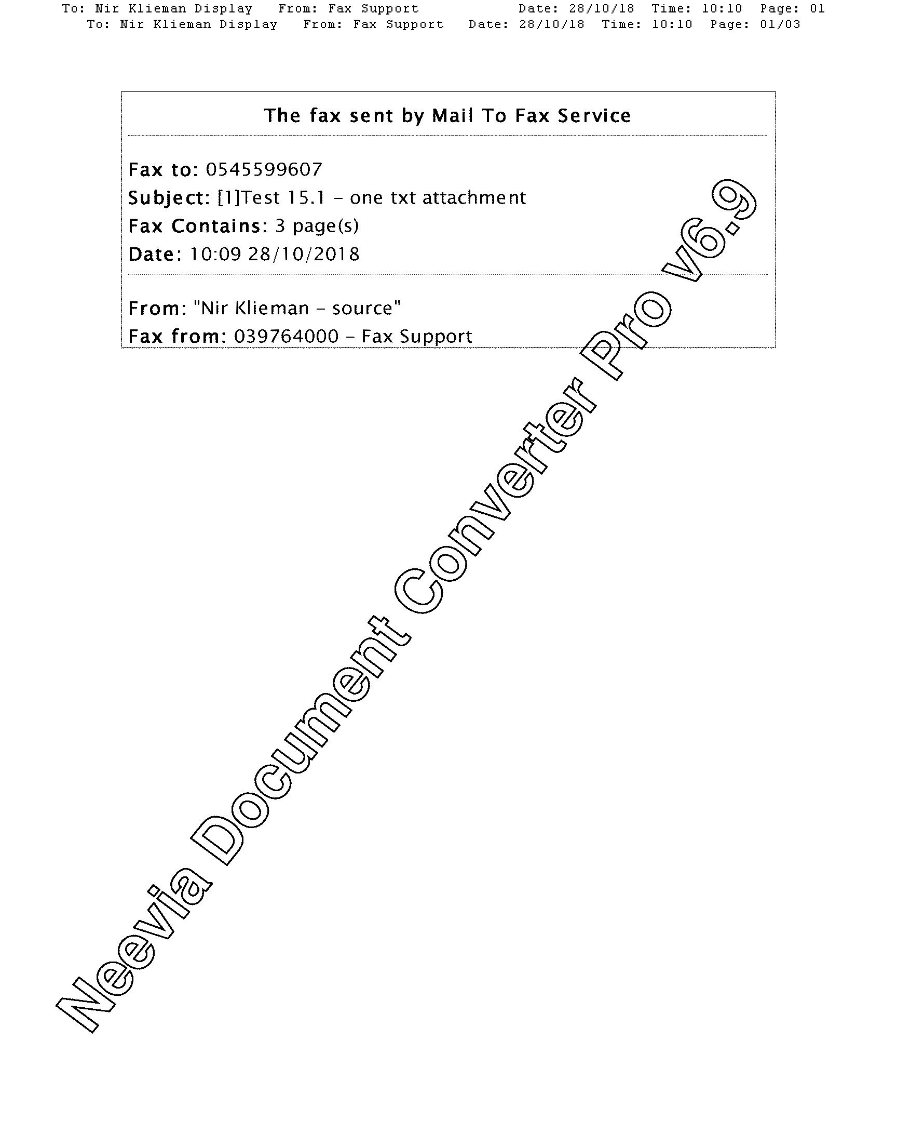
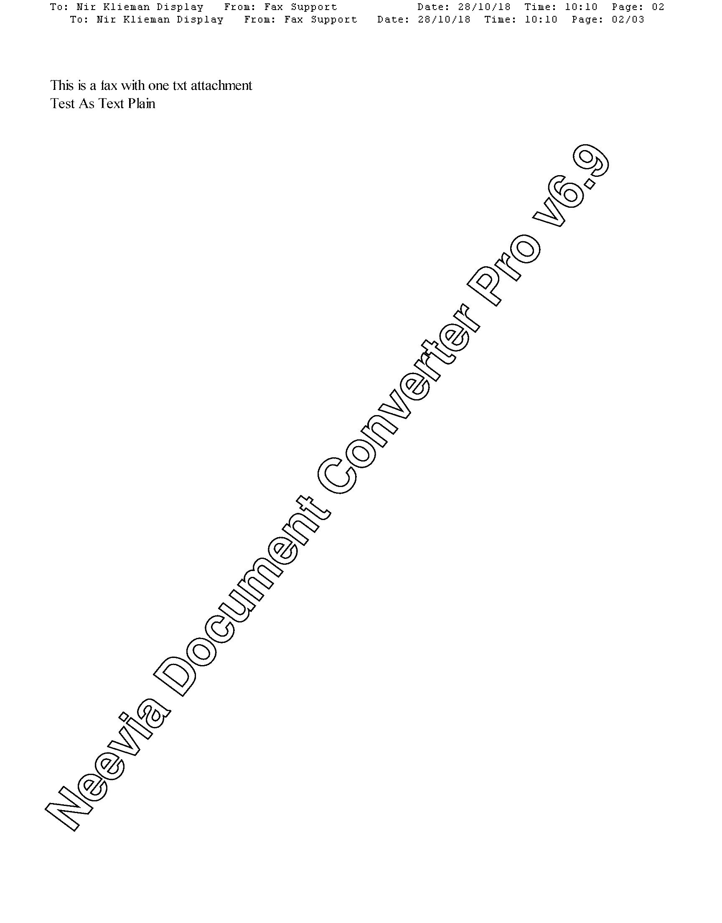
Neevia Document Converter Pro v6.9
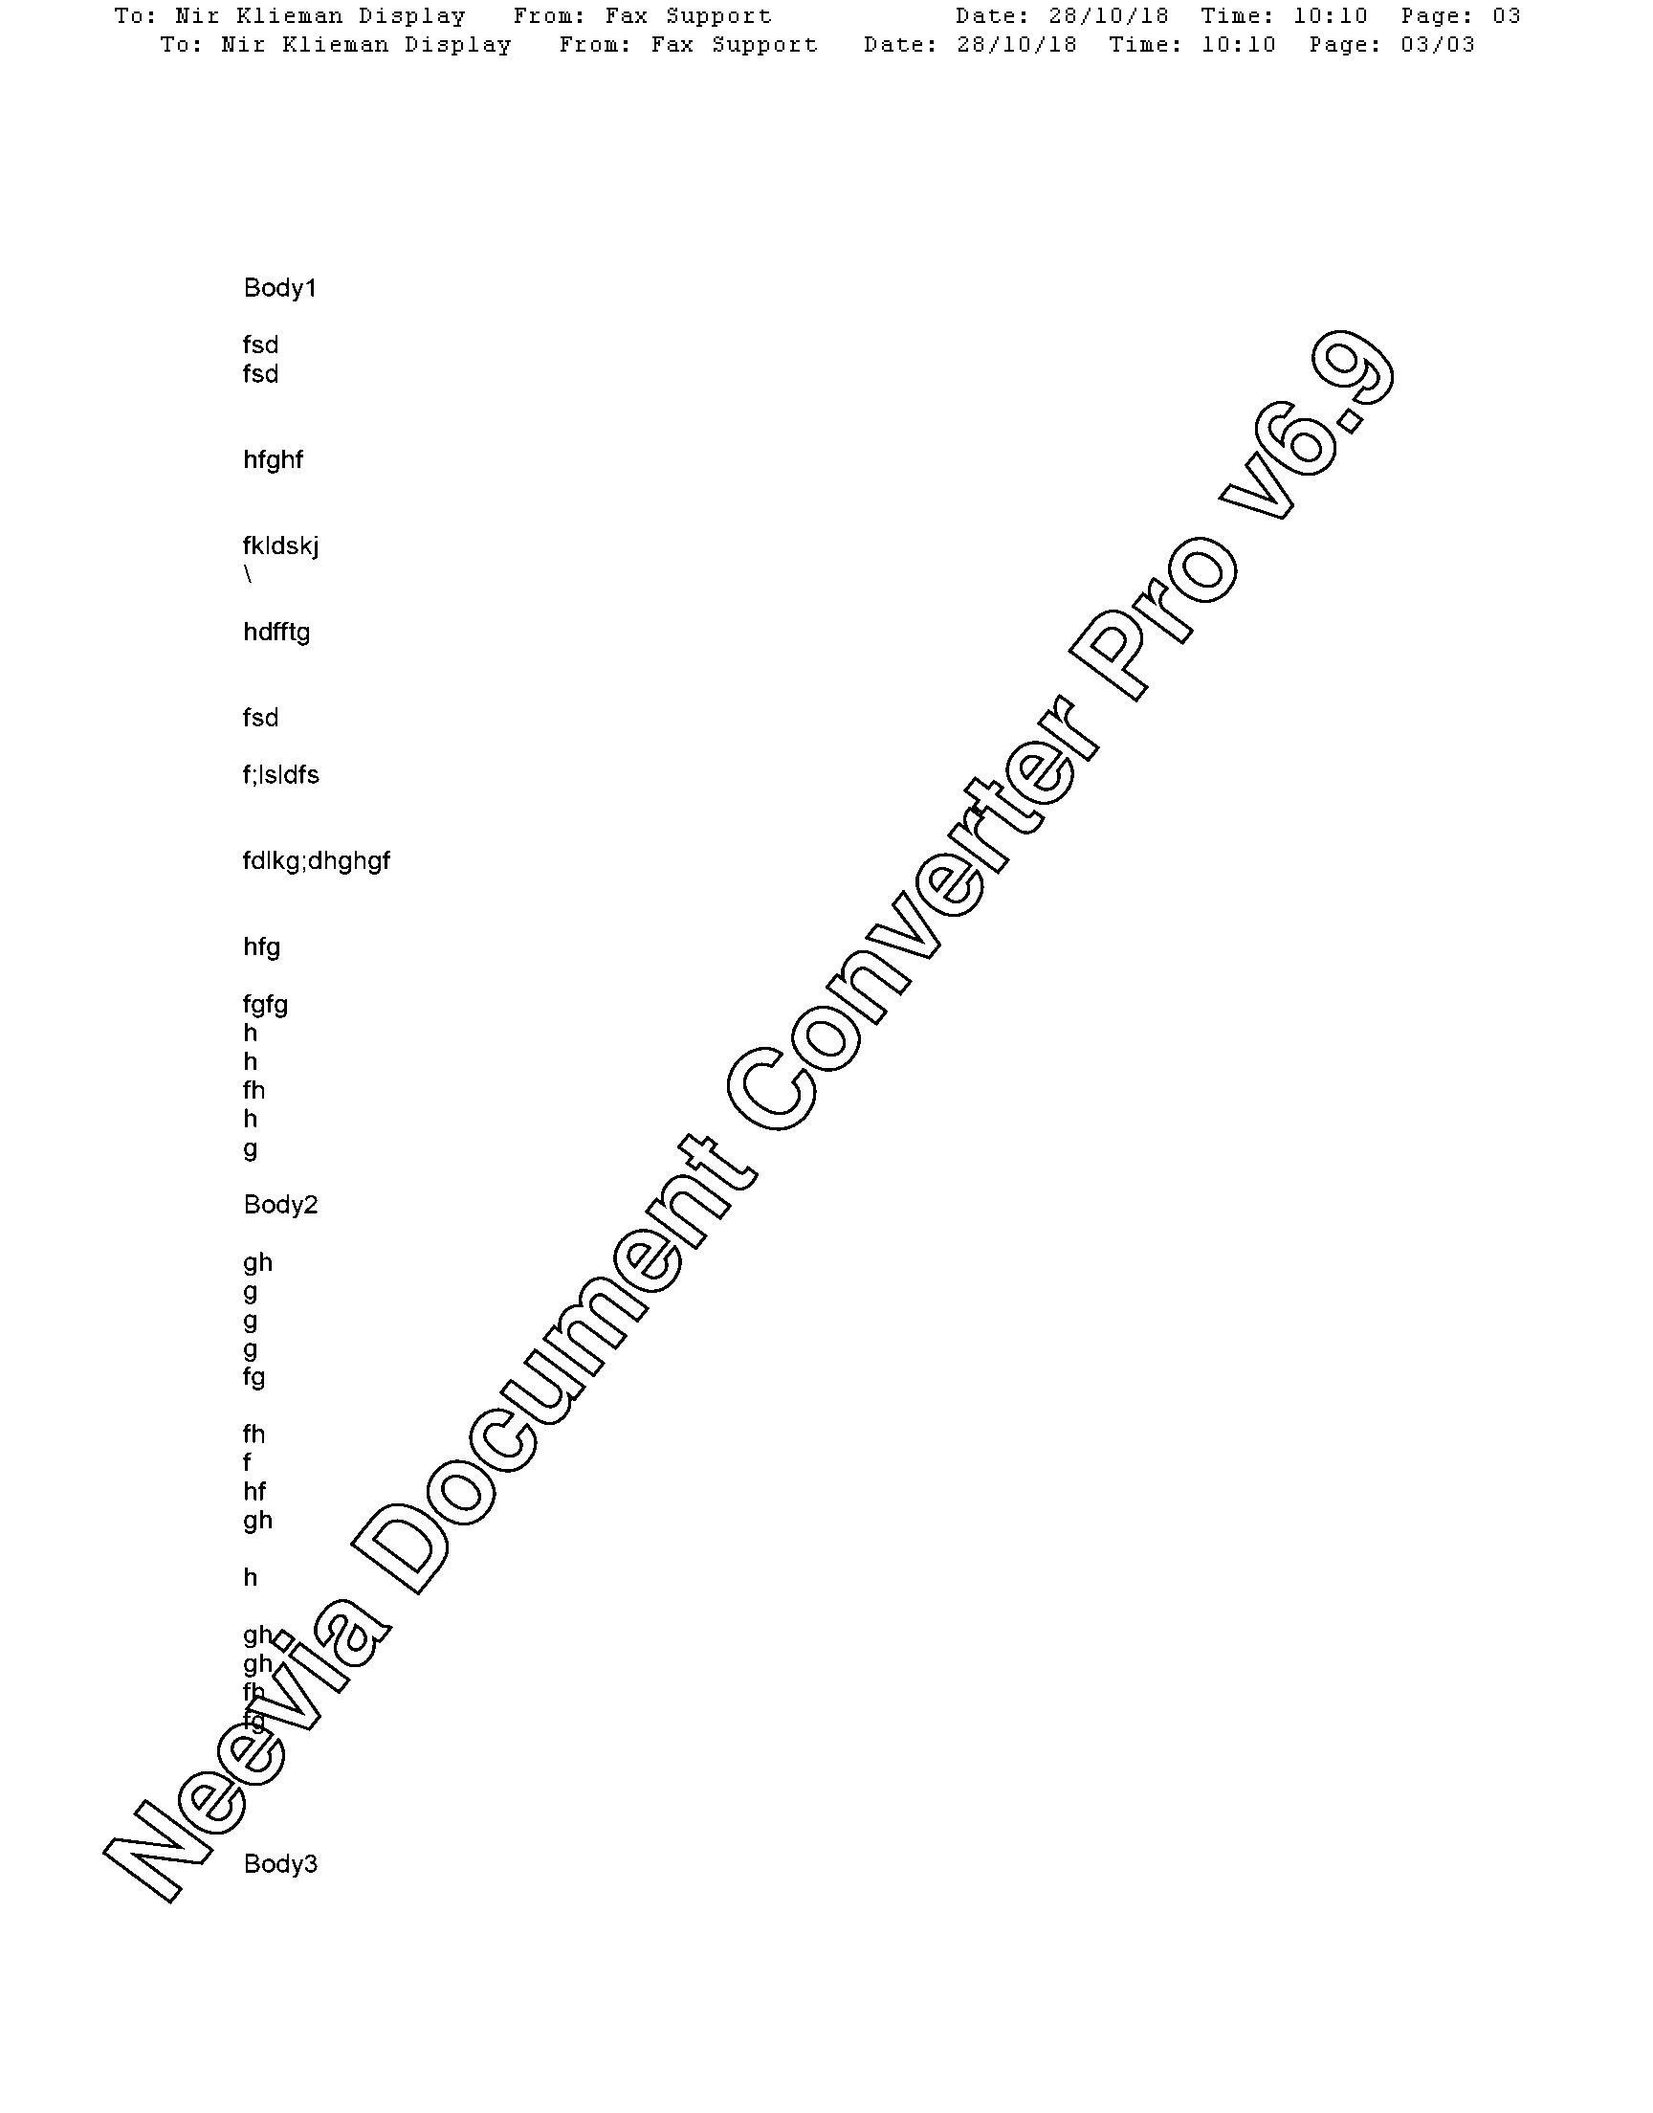
Neevia Document Converter Pro v6.9
Neevia Document Converter Pro v6.9

